OPTIMAL PARTICLE SIZE DISTRIBUTION OF WHITE SUGAR

OPTIMÁLIZÁCIA ROZDELENIA ČASTÍC BIELEHO CUKRU

Marek Bennár^{1,2}, Ester Betoret², Tatiana Bojňanská¹, Dušan Brňo³, Júlia Hambálková³,
Antonín Richter³
¹Slovenská Poľnohospodárska Univerzita v Nitre
²Universitat Politècnica de València, Spain
³Slovenské cukrovary s.r.o. Sereď

INTRODUCTION

Particle size distribution of white sugar has a great importance in the sugar factory, from purification and processing side to the appearance and quality product to the user. The quality of the crystals is of paramount importance for the affination stage in the refining process (8). Affination of raw sugar is carried out with purification by centrifugation and washing. This operation with the fine crystals becomes difficult (2).
To reduce the problems and errors that cause deviation from the given specification in the control of the crystallization and in the centrifugal operation, it is useful to determine crystal size distribution. The Jenoptic Company (Jena, Germany) developed the PSI measuring system. The principle of measurement is based on the diffraction of an incoherent halogen light by particle flow, which is dosed by vibratory conveyor and falls freely through and measuring tube (7).
In the sugar factory Slovenské cukrovary s.r.o. (Slovakia) crystallization of sucrose is produced by the evaporation of water in a supersaturated solution. In the process, the dry substance content of the solution or of the crystal suspension (magma), formed by sugar crystals and mother liquor, increases (5). Consequently, the solubility limit is exceeded and the crystallization process eventually initiated by nucleation. Injection of crystallizate (slurry, seed magma crystallizate) or by crystals already present is introduced to grow (1,3,4,10).

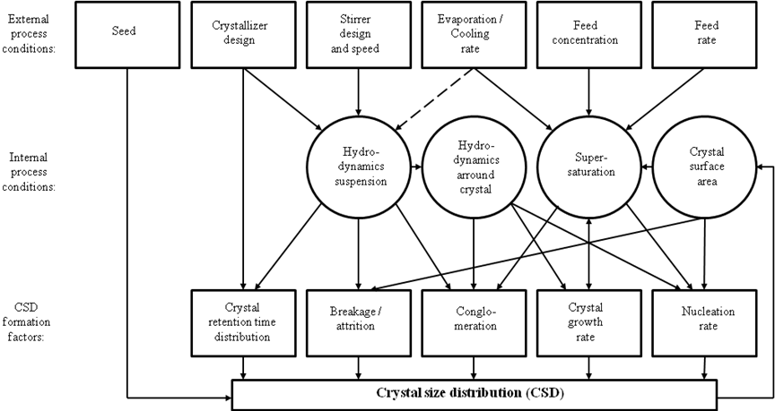
Image 1: Interrelation diagram of suspension crystallization (9)

For energy reasons and because of the thermal sensitivity of the solutions, technical sugar crystallization is carried out under reduced pressure in crystallizer (10).
During the crystallization it is possible to handle with parameters which have influence on particle size of white crystals. Dry matter of juice and volume of the standard syrup in crystallizer as well as heating curve are used in the company Slovenské cukrovary s.r.o. (Slovakia) as constant parameters in the crystallization process. Nevertheless, quantity of slurry (seed magma crystalizate) and volume of slurry massecuite are parameters which can be changed to control the particle size distribution of white sugar (2,10, img. 1).

MATERIALS AND METHODS

The industrial plant for the production of sugar Slovenské cukrovary s.r.o. (img. 2) is located in Sereď (southwestern of Slovakia).
To obtain an optimal particle size distribution of white sugar, five variants, combining quantity of slurry and volume of slurry massecuite, have been tried:

Variant A: 1,000 cm³ of slurry and 15 % of volume of slurry massecuite in crystallizer;
Variant B: 1,000 cm³ of slurry and 19 % of volume of slurry massecuite in crystallizer;
Variant C: 1,100 cm³ of slurry and 19 % of volume of slurry massecuite in crystallizer;
Variant D: 1,100 cm³ of slurry and 20 % of volume of slurry massecuite in crystallizer;
Variant E: 1,100 cm³ of slurry and 22 % of volume of slurry massecuite in crystallizer.

The particle size distribution of white sugar was measured with granulometer AS type 200 (Retsch) (img. 3). This granulometer works with an amplitude range of 1.5 mm·g⁻¹ during 10 minutes. The granulometer has, followed by mesh size, 7 sieves of 2.00, 1.00, 0.80, 0.63, 0.40, 0.32, 0.16 mm and a catch basin. Particle size analysis of samples obtained by sowing has been evaluated by ICUMSA Method GS2-37 (1994) (6). This method defines two parameters: The mean aperture (MA) is the hypothetical mesh aperture of sieve which allows 50% of sugar to pass. The coefficient of variation (CV) indicates the dispersion related to the mean mesh aperture.
To determine the statistical significance of the results an analysis of variance test was carried out with 95% confidence levels (p ≤ 0.05) using the program STATGRAPHICS PLUS v.5.1.

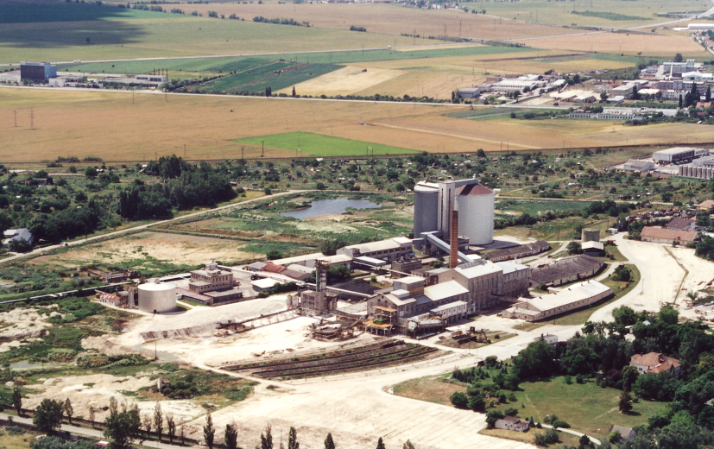 | 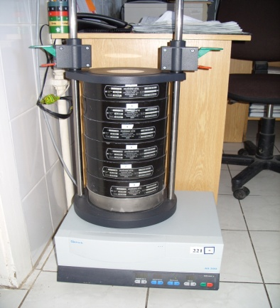
Image 2: Slovenské cukrovary s.r.o. | Image 3: granulometer AS type 200

RESULTS AND DISCUSSION

During the campaign is necessary to obtain the ideal values of particle size distribution of white sugar. The importance of particle size has been demonstrated in the process of centrifugation and washing of raw sugar (2). The results of five variants tied during the campaign are presented in the image 4. The different proportions of crystals are captured by each sieve for all variants using various quantities of slurry and volumes of slurry massecuite added to the evaporating crystallizers.
It is considered from the quality point of white crystal sugar that the 70 % of sugar crystals should have the size higher than 0.400 mm. For all variant this quality point has been obtained (img. 5) but there are others that should be evaluated from process quality point of view. In this case the particle size distribution between the 2nd and 5th sieve should have minimal differences to carry out well sugar centrifugation process and the energy management.

Image 4: Crystals proportions captured by the sieve in all variants

The crystals captured by the sieve with the size of 2.00 mm have not got importance because of small quantity of crystals presented in this sieve. These crystals couldn’t have risen to this size because of the crystallization process time condition.
In the sieve with the size of 1.00 mm different captures of white sugar have been obtained. In the variant A the highest proportion has been obtained. These crystals have had the tendency to rise to this size because of the lower quantities of slurry and slurry massecuite. With the quantity increase of slurry and slurry massecuite has decreased the proportions of crystals in the rest of variants except of the variant E with 1100 cm³ of slurry and 22% of slurry massecuite. Variant A has had the significant difference with the variants B, C and E. In this sieve the variant D has had significant differences with variants A, B and E.
The sieve with the size of 0.80 mm has captured almost the same proportions of crystal (22.31 ± 0.24) for all variants without significant differences. It means that the quantity changes of the slurry and slurry massecuite have not affected these proportions of sugar crystals.
In the sieve which captures the crystals with the size between 0.79 and 0.63 mm so many differences have not been obtained. But we can observe the tendency to increase the crystal proportions from variant A to D. It is obtained by increasing of quantity of crystals germs presented in the slurry massecuite. Significant differences are shown between variant A and D.
In the sieve with the size of 0.40 mm the variant D has got the highest proportion of white sugar crystals what makes this variant different to others. In this sieve the tendency to increase the crystal proportions from variant A to D is higher than in the sieve before. It is obtained by increasing of quantity of crystals germs presented in the slurry massecuite. Obtained proportions present significant difference among variant D and the rest of the variants. In these two sieves the variant E has not confirmed the increasing of crystals. It can be related with high quantity of slurry massecuite.
The proportions in the last two sieves and catch basin are identical with the small deviations which don’t have influence on the process quality.
The best particle size distribution was obtained with the variant D which contains 1100 cm³ of slurry and 20 % volume of slurry massecuite. In the variant D, the crystals proportions captured by the sieves between 1.00 and 0.40 mm have small differences in weight. Noting the proportions of crystals captured for all variables used, the biggest differences are observed in the sieves of 1.00 mm and 0.40 mm due to the existence of crystals germs in the slurry massecuite used for cooking of white sugar. With 1000 cm³ of slurry was used less quantity of crystals germs than with the dosage 1100 cm³ of slurry. Probably in connection with the lower quantity of slurry, the highest proportion of crystals at the 1.00 mm sieve was with the variant A.
Taking into account the volume of slurry massecuite added in crystallizer, a small volume of slurry massecuite causes lower quantity of crystals during cooking of white sugar. In the same way, the higher volume of slurry massecuite into crystallizer produces higher quantity of crystals created during cooking of white sugar. However, volume of slurry massecuite is limited because high volumes produce a large number of crystals, which cannot raise the ideal size from quality process point of view.
Two parameters, the mean aperture (MA) and the coefficient of variation (CV) has been calculated by Butler, Rens and Powers methods to carry out a standardized analysis of the particle size distribution of white sugar. The MA recovers the 50% of the sample and CV as a standard deviation of the distribution. The results obtained showed differences in the values calculated for each variant and method (tab. I.).

Table I: MA, CV and Feasibility of Butler, Rens and Powers methods for each variant
Variant | Method | MA (mm) | CV (%) | Feasibility
A | Butler | 1.07 | 40.38 | no
A | Rens | 0.94 | 34.86 | yes
A | Powers | 1.10 | 53.43 | no
B | Butler | 0.97 | 43.57 | yes
B | Rens | 0.87 | 36.91 | yes
B | Powers | 1.02 | 56.79 | no
C | Butler | 0.95 | 44.26 | yes
C | Rens | 0.86 | 37.14 | yes
C | Powers | 1.01 | 57.49 | no
D | Butler | 0.83 | 48.02 | no
D | Rens | 0.76 | 38.43 | yes
D | Powers | 0.91 | 63.93 | no
E | Butler | 0.96 | 43.28 | yes
E | Rens | 0.86 | 35.19 | yes
E | Powers | 1.02 | 56.54 | no

The methods to carry out a standardized analysis of the particle size distribution of white sugar should confirm the feasibility of all of them. But as is observed in the table 1, the most accurate is the Rens method in which the sieve with the calculated MA for each variant used can really recover 50 % of all white sugar crystals. The Butler method shows positive results only in three variants (B, C, D) what is not enough to recommend it as an adequate method. If comparing the values obtained following the Powers method (tab. I) and the values obtained experimentally (img. 5) using the cumulative proportions of white sugar crystals, it is possible to see that the MA calculated with Powers method is different to that obtained experimentally.

Image 5: Cumulative proportions captured by the sieve in all variants

Van der Poel et al. (10) define CV as a measure of the grain size distribution. The values higher than 35 % are characterized as a wide, poor distribution. The results of CV obtained for each variant and each method are higher than 35% what means that the measures of the particle size distribution have had wide and poor distribution. But we can observe that the Rens method has the values of CV the very close to 35%. The values of CV in the Butler and Powers methods are too high. It means that from the particle size distribution point of view these methods evaluate the distribution as wide and poor. Nowadays it is difficult to consider which method evaluates the particle side distribution correctly and it is necessary to find one unique method which will be useful to determine well the particle size distribution of white sugar.

CONCLUSIONS

The obtained results showed that it is possible to optimize the crystallization process using slurry and volume of slurry massecuite in sugar beet industry. The best method for evaluation of particle size of white sugar is Rens method because the results obtained with this method confirm that the MA for each variant used can really recover 50% of all white sugar crystals and the values of CV are the most close to 35 %.

ABSTRACT

Particle size distribution of white sugar, as a quality parameter, has a great importance in the sugar beet industry. During the crystallization procedure it is possible to handle with different parameters which have influence on particle size of crystals. Dry matter of the juice and volume of the standard syrup in crystallizer as well as heating curve are used in the company Slovenské cukrovary s.r.o. (Slovakia) as constant parameters in the crystallization process. Quantity of slurry (seed magma crystalizate) and volume of slurry massecuite are parameters which can be changed to control the particle size distribution of white sugar. Five variants of those parameters have been tried to obtain an optimal particle size distribution. The particle size distribution was measured with granulometer AS type 200 (Retsch). The samples obtained by sowing have been evaluated by ICUMSA Method GS 2-37 (1994). The relationship between variable parameters and particle size distribution has been demonstrated. The obtained results showed that it is possible to optimize the crystallization process using 19% of slurry and 1100 cm³ of volume of slurry massecuite as variables in sugar beet industry.

Key words: sugar beet industry, crystallization, slurry, ICUMSA Method GS2-37 (1994), particle size distribution.

REFERENCES

- Bennár, M. (2010): Optimization the yield increase of sugar in obtaining sucrose from sugar beet - doctoral thesis, Slovak University of Agriculture in Nitra, Slovakia.
- Chapman, F.M. (1963): Honig, P. (Ed.): Priciples of Sugar Technology, Vol. 3 Elsevier, Amsterdam, s. 223 – 260.
- Gebler, J. – Bubník, Z. (1993): Kontinuální navážení cukrovin IV. Výsledky meření. Listy cukrov. řepař., 109, 1993 (1), s. 15 – 23.
- Ginal, S. (1996): Krystalizace cukru s očkovacím zádělem. Listy cukrov. řepař., 112, 1996 (5), s. 142 – 145.
- Hartel, R. (2001): Crystallization in Foods. Aspen Publishers: Gaithersburg. 2001,
- ICUMSA Method GS 2-37 (1994): Stanovenie rozdelenia veľkosti častíc bieleho cukru osevom. Listy cukrov. řepař., 124, 2008 (5-6), s. 180 – 183.
- Lőffler, W. (1997) in: van der Poel, P. W. – Schiweck, H. – Schwartz, T. (1998): Sugar Technology, Beet and Cane Sugar Manufacture. Verlag Dr. Albert Bartens KG, Berlin.
- Meikle, J. (1990) in: Clarke, M. A. (Ed.): Proceedings Workshop on Raw and White Sugar Quality. Dr. Albert Bartens, Berlin, 28 – 32.
- Pot, A. - Kuijvenhoven, L.J. - de Nie, L. - de Jong, E.J. (1984): A study on the formation factors of crystal size distribution in industrial sucrose crystallizers. Zuckerind., 109, 1984 (4), s. 305 – 313
- van der Poel, P. W. – Schiweck, H. – Schwartz, T. (1998): Sugar Technology, Beet and Cane Sugar Manufacture. Verlag Dr. Albert Bartens KG, Berlin.

ABSTRAKT

Stanovenie rozdelenia častíc bieleho cukru, ako kvalitatívny parameter, má značnú importanciu v cukrovarníctve. V Slovenských cukrovaroch s.r.o. (Slovakia) je kryštalizácia docielená odparovaním vody s cieľom dosiahnuť presýtenie. Varenie cukrovín má až na malé odchýlky rovnaký postup. Tento postup sa dá ovplyvniť viacerými faktormi, avšak iba pár z nich sa počas kampane mení a tým sa aj ovplyvňuje granulometrické zloženie produktu. Medzi stále veličiny, ktoré svoju hodnotu nemenia, patria; sušina šťavy, pri ktorej sa mikroočko pridáva do očkovacieho varostroja, sušina šťavy, pri ktorej sa očkovacia cukrovina pridáva do varostroja, hladina štandardného sirupu vo varostroji pri základnom náťahu a varná krivka. Medzi veličiny, ktoré sa menia a tým vplývajú na granulometrické zloženie produktu patria množstvo mikroočka a množstvo očkovacej cukroviny pridávanej do varostrojov. Bolo realizovaných päť variantov pre dosiahnutie ideálneho rozdelienia častíc bieleho cukru. Granulometrické zloženie produktu bolo merané pomocou granulometra AS 200 Retsch a vyhodnotené ICUMSA Method GS2-37 (1994). Vzťah medzi premennými veličinami a rozdelením častíc bieleho cukru bol dokázaný. Dosiahnuté výsledky potvrdzujú možnosť optimalizácie krystalizačného procesu prostredníctvom množstva mikroočka a množstva očkovacej cukroviny pridávanej do varostrojov.

Kľúčové slová: cukrovarníctvo, kryštalizácia, mikroočko, ICUMSA Method GS2-37 (1994).

Contact address:

Ing. Marek Bennár, PhD. MSc., Ing. Ester Betoret, MSc., Institute of Food Engineering for Development, Department of Food Technology, Polytechnic University of Valencia, Camino de Vera s/N, 46022 Valencia, Spain, Tel. +34 96 387 9371, e-mail: marek_bennar@hotmail.com

doc. Ing. Tatiana Bojňanská, CSc., Slovenská poľnohospodárska univerzita v Nitre, FBP, KSSRP, Tr. A. Hlinku 2. Tel.: 037 641 5815, e-mail: tatiana.bojnanska@uniag.sk

Ing. Antonín Richter, Ing. Júlia Hambálková, Ing. Dušan Brňo, Slovenské cukrovary s.r.o. Sereď, Cukrovarská 726, Tel. 031 788 4101, e-mail: antonin.richter@agrana.com

