Effect of Seeds Stimulation on Sugar Beet Productivity

Prośba-Białczyk Urszula¹, Szajsner Hanna ¹, Grzyś Edward¹, Demczuk Anna¹,
Sacała Elżbieta¹, Bąk Krzysztof ²

¹ Wrocław University of Environmental and Life Sciences, ² Syngenta Seeds

Urszula Prośba-Białczyk (e-mail: urszula.prosba-bialczyk@up.wroc.pl), Wrocław University of Environmental and Life Sciences, The Faculty of Life Sciences and Technology, Poland 50-363 Wrocław, Plac Grunwaldzki 24 a.

A b s t r a c t: The study deals with the influence of pre-sowing seed material stimulation with the use of energ’hill (Eh) technology and different radiation doses of the semiconductor laser on germination and productivity of sugar beet. The experiment was conducted in laboratory conditions and in field experiments, according to the method independent series, in four replications. Positive effect of morphological features stimulation was observed for the Eh seed breeding program. After irradiation of the beet-seed balls, substantially higher concentration of carotenoids and chlorophylls in the seedlings coming from the Eh program as well as the increase in the indicator value (chlorophyll a and chlorophyll b ratio) was noticed. The plants developed from the seeds obtained from Eh program and from the irradiated seeds were characterized by higher yield than the plants emerged from non-stimulated seeds. Seeds preparation in Eh program had positive influence on yields and it lowered the content of saccharose and molasses forming substances.

Key words: sugar beet, energ’hill, laser irradiation, germination, pigments, yield, saccharose, molasses forming substances.

INTRODUCTION

The quality of sowing material of each farm plant and sugar beet in particular, is one of the most important factors having influence on productivity and on the efficiency of production. Seeds improvement favourably influences most of all plants vigour and in sugar beet growing it may additionally affect yielding level and quality features of roots (1, 2, 4). In the improvement of sowing material of sugar beet widely applied are mechanical methods such as calibration of seeds and chemical ones that aim at protecting seedlings against pathogens in early stages of development. In the improvement of farm plants’ seeds other methods can also be applied, among others electric field, magnetic field, microwave radiation, ionizing radiation, visible light, millimetre radiation and laser radiation (1, 4, 6, 7, 8, 9, 11). According to researchers the effects of pre-sowing stimulation of farm plants depend on the following: the weather during vegetation, plant species, genotype, cultivar and also fertilization. In the research the interaction between cultivars and the multiple of radiation dose was also demonstrated.
In the experiments carried out by Wójcik and all (11) with the application of laser light as the sugar beet improving factor different doses of laser rays He-Ne, 1-, 2-, 3- and 4 multiple of the basic dose were used. The authors observed the increase in yielding under the influence of twofold dose and the increase in sugar content under the influence of threefold dose.
Some reports about a positive influence of laser irradiation on yielding level and on saccharose content prove the necessity of further research in order to find out more about cultivars’ reactions and their interaction with growing conditions.
The aim of the research was to establish the influence of sugar beet-seed balls processing on the germination ability, the course of early developmental stages and the content of photosynthetic pigments. From a practical point of view it would be also interesting to estimate the influence of seeds laser light stimulation on yielding and technological qualities of roots.

MATERIAL AND METHODS

The plant material used in the research in laboratory and field experiment was two cultivar of sugar beet Traviata (triploid, sugar type) and Ruveta (diploid sugar- normal type). For each cultivars standard, non-stimulated beet-seeds and improved beet-seeds from energ’hill (Eh) program and laser irradiated seeds were sown.
Before the laboratory experiment was set up the seeds had been irradiated with semiconductor laser (CTL – 1106 MX). The irradiated surface was established with the use of scanner (CTL 1202 S) cooperating with the laser. The series of the following doses was used: the threefold (D3), fivefold (D5), sevenfold (D7) and tenfold (D10) of the basic dose equivalent to 2.5 • 10⁻¹J • cm⁻². Moreover, the material was processed by the means of Eh method. There was also the control (variant C) i.e. sugar beet seeds that were not irradiated. The sowing of the control seeds, the laser-irradiated seeds and the stimulation in a Eh program took place in the first 24 hours after irradiation on Petri dishes in four replications. Seeding material of sugar beet was placed in a germination apparatus in the conditions of controlled temperature and humidity. Furthermore, the measurements of morphological features of the seedlings emerged from the control and the irradiated seeds were carried out, namely the length of radicles and cotyledons together with hypocotyls.
In the research the content of photosynthetic pigments in seedlings was Traviata cultivar and in the field experiment was Traviata and Ruveta cultivars emerged from the standard seeds, the Eh seeds and the laser stimulated seeds in two doses D5 and D7 was determined. The content of carotenoids and chlorophylls in the leaves of sugar beet seedlings was estimated by using spectrophotometer. Pigments were extracted by means of 80 % acetone, whereas the absorbance was measured by using spectrophotometer CECIL CE 2011 at a wavelength of 470, 647 and 663 nm. The content of pigments was given in mg * g-1 of fresh matter.
The main criterion for sugar beet productivity was yielding and saccharose and molasses forming substances .The parameters of roots technological value – the saccharose and K, Na and N – α amino acids content.
Laboratory research the length of radicle and cotyledon and hypocotyl was conducted by the means of independent series method and field experiment was carried out according to the method of split-plot in three replications. The results were analysed statistically according to the methodology The diversity of cultivars, the laser light doses and the interaction between these two factors was assessed. Test F was applied to estimate the gravity of differences between the variants used in the experiment and Duncan test to isolate homogenous groups.
The experiment was conducted in the climatic conditions of Lower Silesia on grey-brown podsolic soil of granulometric composition of medium loam classified as good wheat complex (pH 6,1-6,5) and rich in minerals.

RESULTS

The length of radicle showed significant diversity under the influence of the applied laser light doses, cultivars and the interaction between these two factors (img.1). Sugar beet cultivars created two separate homogenous groups regarding the length of radicle. Ruveta produced the longest radicle (33.64 mm), whereas Traviata belonged to two group with significantly the shortest radicle (27.55 mm). Significantly the longest radicle produced the seedlings from Eh program.
As to the length of cotyledon and hypocotyl, statistical analysis has shown a significant differentiation of laser light doses and interaction between a dose and a cultivars (img. 2). The obtained interaction proved substantially the best effect of hypocotyl’s length stimulation in cultivars. Traviata the highest values in comparison with the control were observed after the application of D10 dose, and Ruveta of doses D3, D5 and D7. Seedlings from Eh breeding program were characterized by substantially the longest cotyledons and hypocotyls.
Showing higher sensitivity to the applied methods, significantly higher amount of carotenoids and chlorophyll in sugar beet seedlings from Eh seeds was found (img. 3a and b). There were no essential changes in the amount of carotenoids content in the seedlings emerged from the laser stimulated seeds in comparison with the control seedlings. A significantly higher amount of chlorophylls in the seedlings emerged from laser stimulated seeds was not observed (img. 3b). The ratio of chlorophyll a to chlorophyll b was 2.53 to 2.81 depending on the examined object (Table 1). It is worth emphasizing that the growth of this rate was especially significant for the seedlings of emerged from the laser stimulated seeds.
Seeds stimulation in the Eh reproduction program and seeds irradiation had influence on the yielding level and sucrose and molasses forming substances content (Table 2). The effect of seeds stimulation on the yielding level was not observed in Ruveta cultivar. On yielding of Traviata cultivar positively influenced the preparation of the seeds in Eh program.
The stimulation of seeds by laser irradiation and in the Eh reproduction program modified the sucrose content. Substantial differences between both cultivars were observed. In Ruveta variety the sucrose content of plants developed from of stimulation seeds was not different when compared to that of the roots of plants from non-stimulated seeds. In Traviata variety it was higher when compared to non-stimulated seeds. Cultivars reaction to seeds stimulation on was, however, distinctly differed regarding sodium and potassium cations content

DISCUSSION

In the research the favourable influence of laser light and Eh method on the lengthening of roots and hypocotyls in the examined genotypes of sugar beet was observed. It proves that the changes evoked both in the irradiated seeds and in the seeds from the Eh program also cause the changes in the dynamics of development of the emerged seedlings. In the literature concerning the influence of laser irradiation on plant material there is no information on semiconductor laser impact used in our research.
In the experiment a significant enhancement in germination ability of the stimulated sugar beet balls was observed. It can have a great importance on a farm scale, especially in the case of unfavourable atmospheric conditions during germination time. The seeds with higher germination ability and the enhanced developmental process have bigger chance of development in case of spring drought. The favourable influence of seed laser irradiation on the germination process and on seedling emergence demonstrated (1, 2, 10). Laser light turned out to be useful also in the improvement of long-stored materials with the sowing value lowered due to a long lay-in time.
The content of photosynthetic pigments in leaves is only one of the factors having influence on the intensity of photosynthesis process. According to some authors (3, 8, 10) its content in sugar beet leaves is not closely connected with the intensity of photosynthesis process. It should be stressed that chlorophyll content in plants leaves is not only the measure of photosynthesis intensity but also the indicator of nitrogen content in plants (5).
The research confirmed, already indicated by other authors the influence of seeds improvement on sugar beet productivity. The plants emerged from seeds obtained from Eh breeding and improvement program as well as the plants from the seeds irradiated with laser were characterized by higher productive potential than those emerged from standard beet-seed balls.
The results of field and laboratory experiments show the possibility of modification of the yielding level and roots technological quality under the influence of Eh program and seeds stimulation with laser light. The effect of Eh breeding and improvement method and laser light stimulation interact with cultivars’ genotype in the aspect of yielding level and the features conditioning technological value of roots. In the conducted experiments, similarly to Wójcik and others research (11), favourable influence of laser light irradiation on beet yielding and saccharose content was proven.

CONCLUSIONS

- Seeds preparation in the Eh program and pre-sowing laser irradiation had favourable influence on the growth and development of seedlings and on sugar beet productivity.
- Energ’hill technology caused a significantly higher carotenoids and chlorophylls content in leaves and laser light irradiation favourably modified relation of chlorophyll a to chlorophyll b.
- Plants emerged from the seeds the Eh program were characterized higher yielding level than plants developed from standard seeds. The effect of pre-sowing irradiation with laser radiation was conditioned by cultivars’ genotype.
- Seeds improvement in the Eh program had a favourable influence on roots yield level and their technological quality. Seeds stimulation, especially laser irradiation, had a positive influence on the saccharose content.
- The preparation of seeds in the Eh program cause the reduction of molasses forming substances - N – α amino acids as well as sodium and potassium cations was observed.

REFERENCES

- Gładyszewska B., Koper R. 2002.: Determination of a laser radiation energy dose in the seed biostimulation process. Acta Agrophysica, 62, 15-23.
- Hermandez A.C., Dominguez P.A., Cruz O.A., Ivanov R., Caballo C.A., Zepeda B.R. 2010: Laser in agriculture. Int. Agrophys., 24. 407-422.
- Kacharava N., Chanishvili S., Badridze G., Chkhubianishvili E., Janukashvili N., 2009. Effect of seed irradiation on the content of antioxidants in leaves of Kidney bean, Cabbage and Beet cultivars. Australian Journal of Crop Science 3(3): 137-145.
- Pietruszewski S., Wójcik S.2000a: Effect of magnetic field on yield and chemical composition of sugar beet roots. Int. Agrophysics. 14, 89-92.
- Pulkrabek J., Jozefyova L., Famera O., Stepanek P., 2001. Differences in chlorophyll content in leaves of sugar beet. Rostlinna vyroba, 47(6): 241-246.
- Rochalska M., 2005. Influence of frequent magnetic field on chlorophyll content in leaves of sugar beet plants. Nukleonika 50 (Supplement 2): 25-28.
- Rochalska M., Grabowska K., Ziarnik A. 2008. Impact of low frequency magnetic fields on yield and quality of sugar beet. Int. Agrophysics. 23: 163-174.
- Rochalska M., 2005. Influence of frequent magnetic field on chlorophyll content in leaves of sugar beet plants. Nukleonika 50 (Supplement 2): 25-28.
- Rochalska M., Orzeszko-Rywka A. 2008. Influence of alternating magnetic field on respiration of sugar beet seeds. Inter. Agrophysics. 22; 255-260.
- Siddiqui M.H., Khan M.M.A., Khan M.N., Mohammad F., Naeem M., 2006. Hill reaction, photosynthesis and chlorophyll content in non-sugar-producing (Turnip, Brassica rapa L.) and sugar-producing (Sugar beet, Beta vulgaris L.) root crop plants. Turk. J Biol., 30: 153-155.
- Wójcik S., Dziamba M., Pietruszewski S.: 2004. Effect of microwave radiation on the field and technological quality of sugar beet roots. Acta Agrophysics. 3/3: 623-630.

Image 1. Effect of pre-sowing stimulation on root lenght
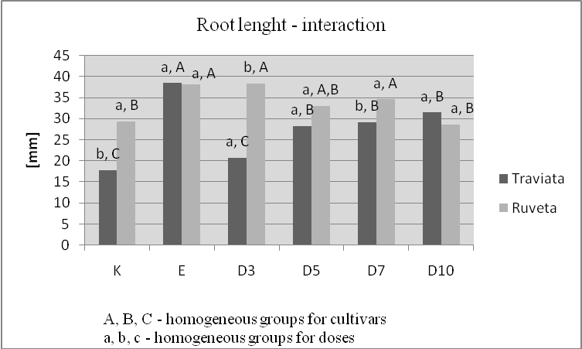

Image 2. Effect of pre-sowing stimulation on hypocotyl and seed leaf lenght
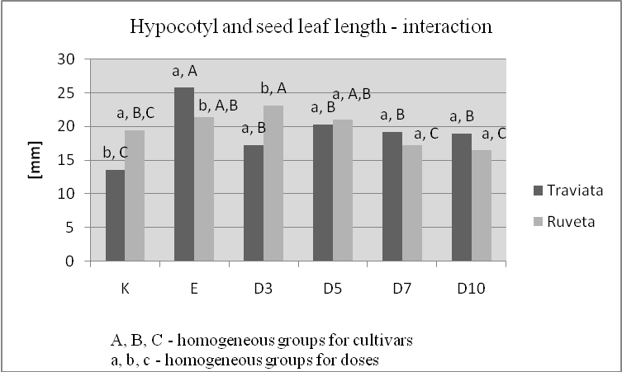

Image 3a and 3b. Effect of pre-sowing stimulation on carotenoids (a) and chlorophylls (b)
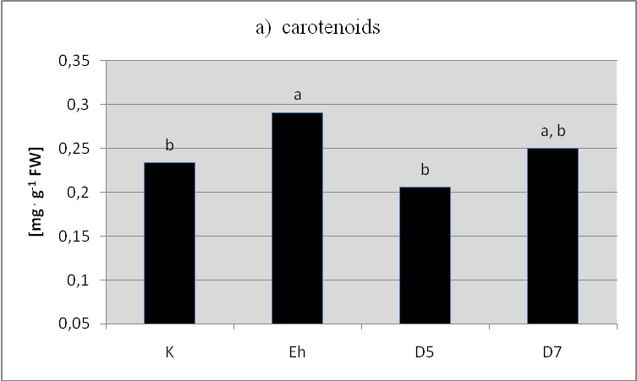
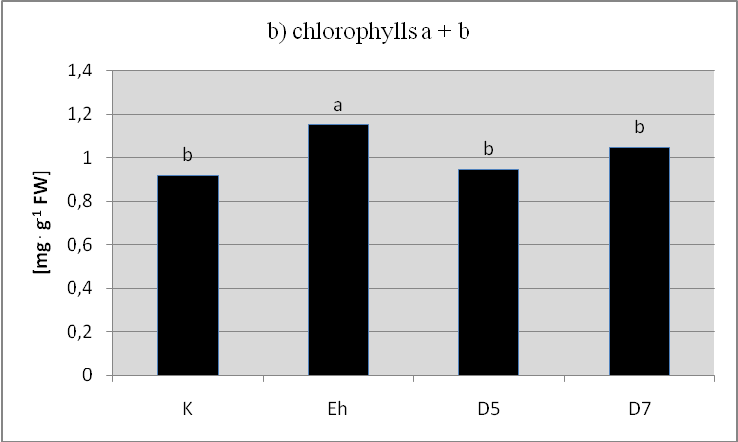

Table 1. The ratio of chlorophyll a to chlorophyll b in leaves of sugar beet seedlings
Treatment | chl a / chl b
Control | 2,53
Energ ‘hill | 2,67
D5 | 2,79
D7 | 2,81
LSD (α ≤ 0,05) | 0,06

Table 2. Effect of stimulation of sugar beet seeds on the yield and root morphological characteristics
Parametr | Cultivar | Cobtrol | Energ ‘hill | Laser D5 | Laser D7
Yield of roots t·ha⁻¹ | Ruveta | 58,8 | 62,7 | 59,2 | 61,9
Yield of roots t·ha⁻¹ | Traviata | 60,4 | 67,2 | 59,2 | 61,9
LSD | 4,8* 5,7**
Sacharoza [%] | Ruveta | 16,14 | 16,08 | 16,05 | 16,35
Sacharoza [%] | Traviata | 16,03 | 16,35 | 16,52 | 16,70
LSD | 0,25* 0,28**
N-α amino  acids | Ruveta | 26,7 | 25,9 | 27,4 | 27,8
N-α amino  acids | Traviata | 22,2 | 20,3 | 21,8 | 21,9
LSD | 1,85* 2,62**
Sodium | Ruveta | 3,53 | 3,24 | 3,47 | 3,48
Sodium | Traviata | 3,18 | 2,68 | 2,79 | 2,95
LSD | 0,38* 0,68**
Potassium | Ruveta | 38,8 | 36,0 | 37,4 | 37,0
Potassium | Traviata | 33,6 | 30,8 | 32,9 | 33,6
LSD | 1,5* 2,2**
* LSD stimulation of seed, ** LSD interaction stimulation of seed and cultivar

